**Date: 18-01-2022 to 21-01-2022**

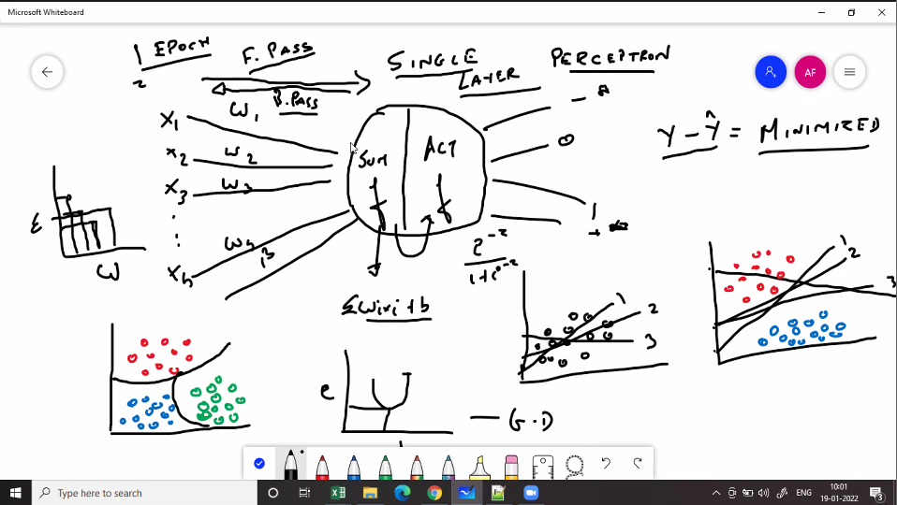

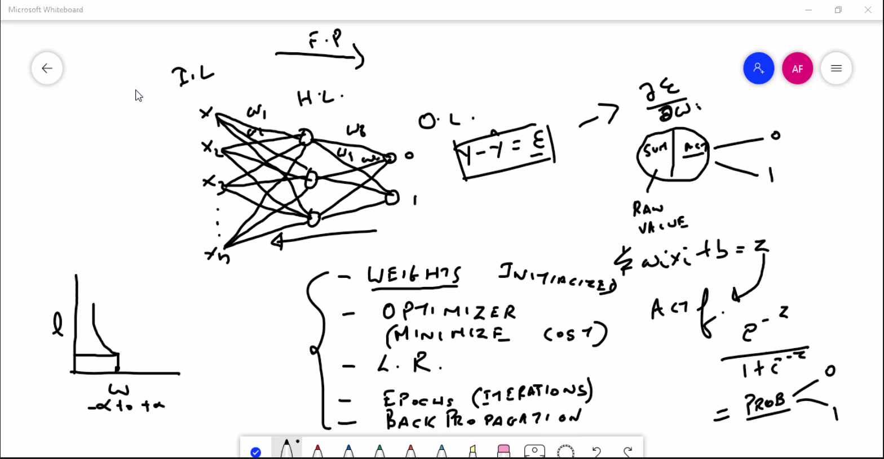

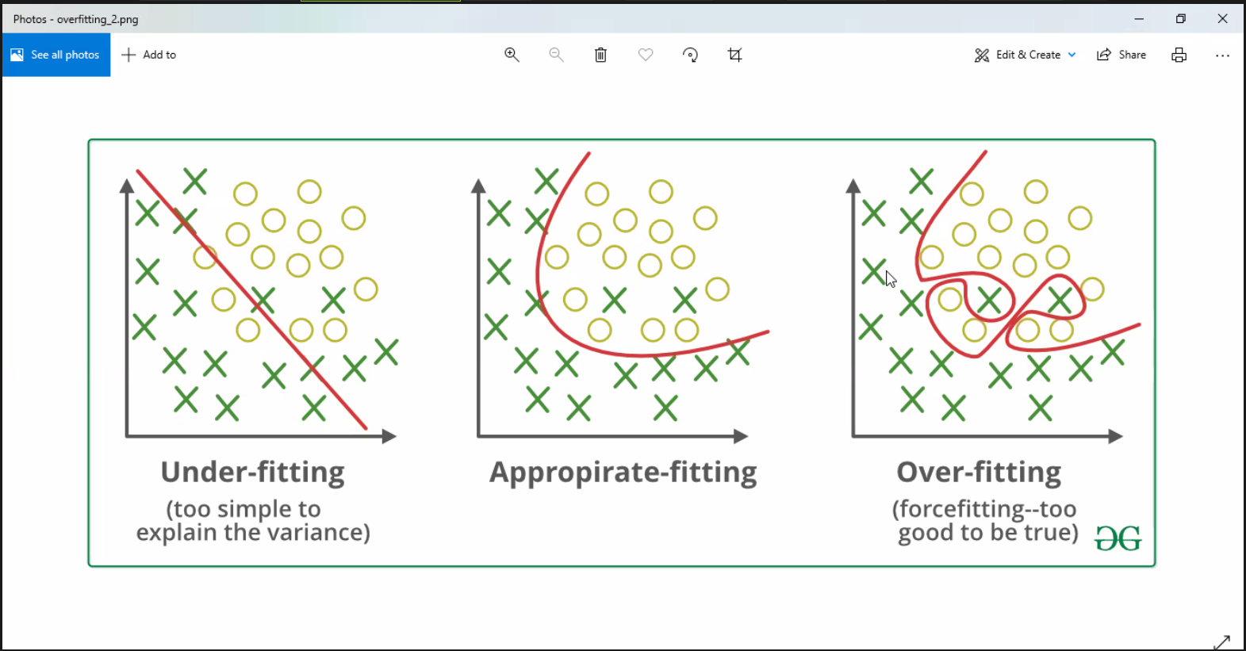

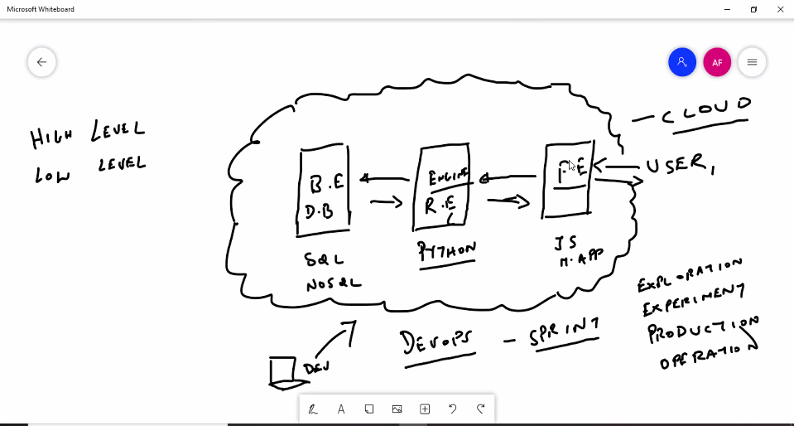

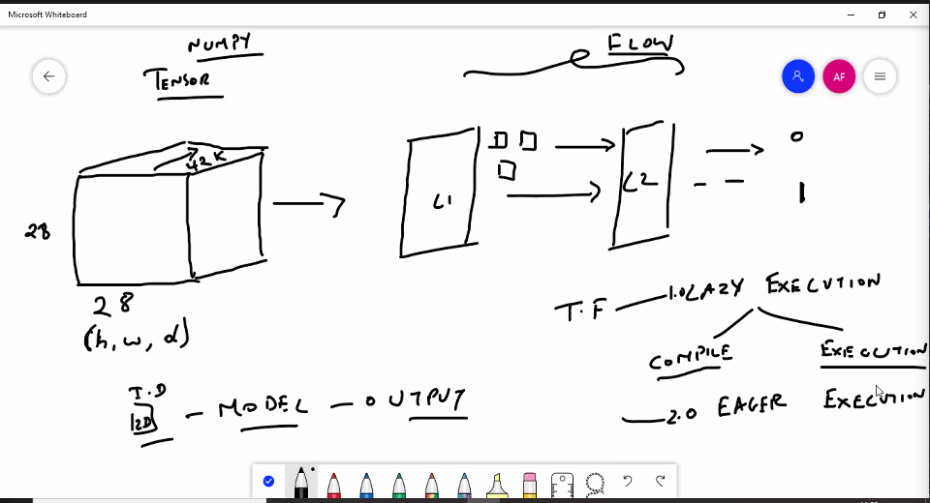

**Date: 25-01-2022**

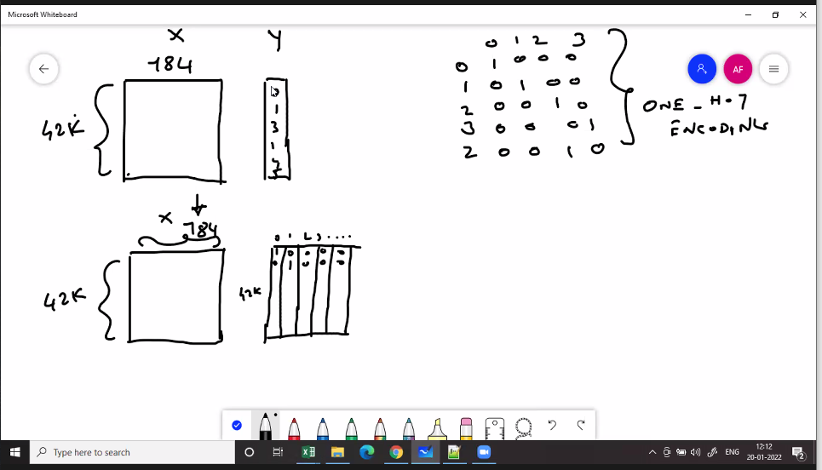

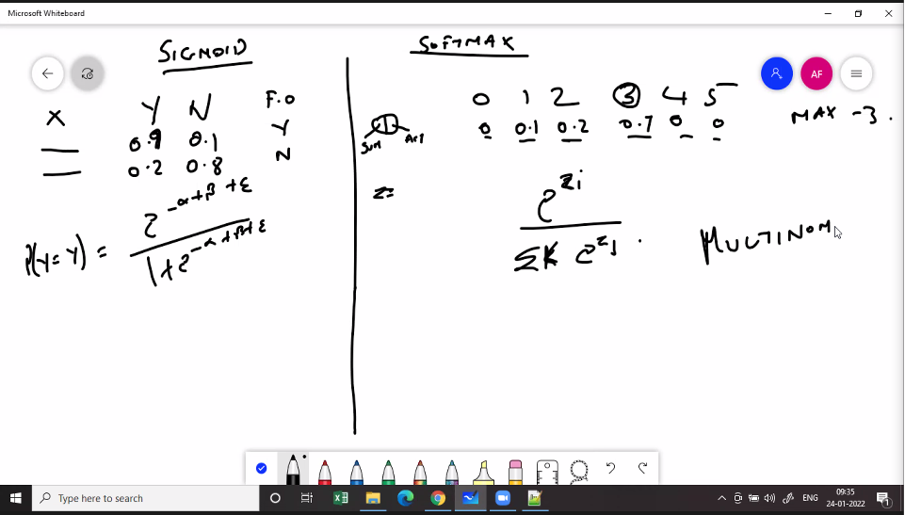

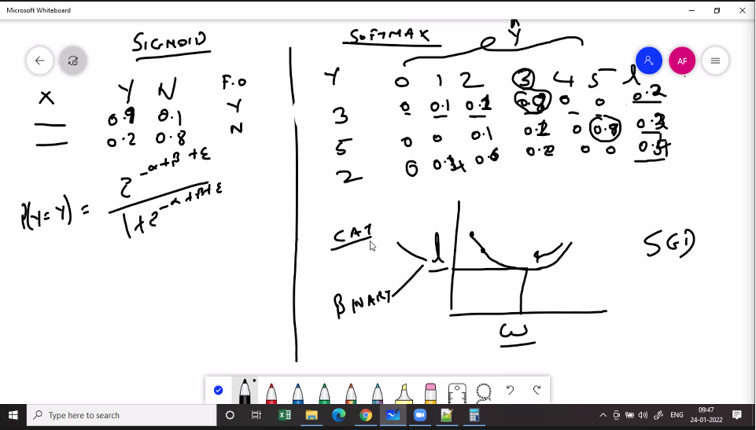

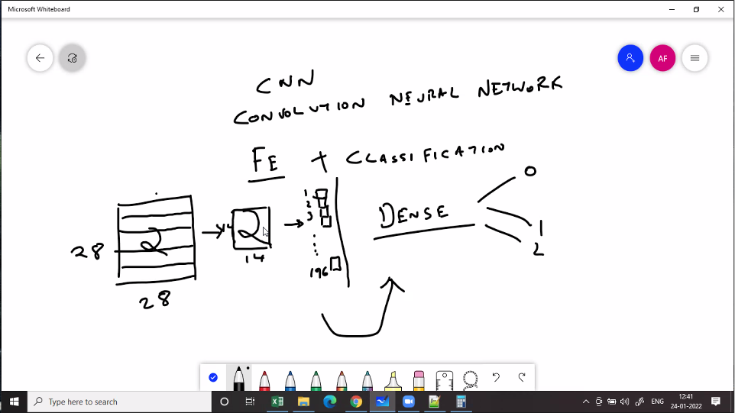

Approach:1) Load the data and check shape of data2) Set up of data as tensors3) Initialize a model - Sequential: Sequence of layers - Functional: Multi models. Transfer learning (VGG16, VGG19, Inception..)4) Set up the layers - MLP: Dense Layers, Dropout, Regularization - CNN: Convolutional layers, Pooling layers, flatten etc. - RNN: Simple RNN Layer, Bi-directional RNN etc. - LSTM:.....5) Compile - Optimizer: SGD, ADAM - Loss Function: Regression or Classification - Accuracy: Classification problem - Checkpoint6) Fit - Train Dataset - Test dataset - Epochs (iterations) - Verbose: 1,2,3....7) Predict - predict for new data

**Date: 27-01-2022**

**CNN Architecture**

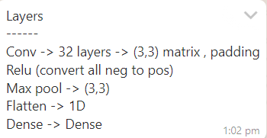

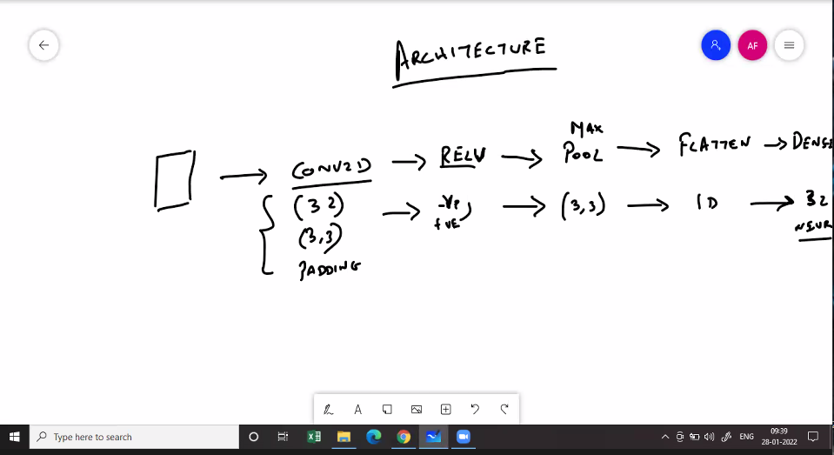

**Date: 02-02-2022**

**NLP**

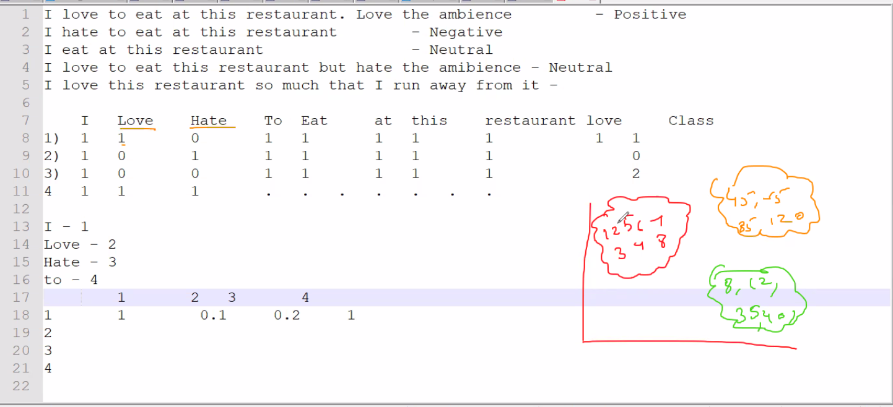

**Date: 04-02-2022**

**Time Series Lags:**

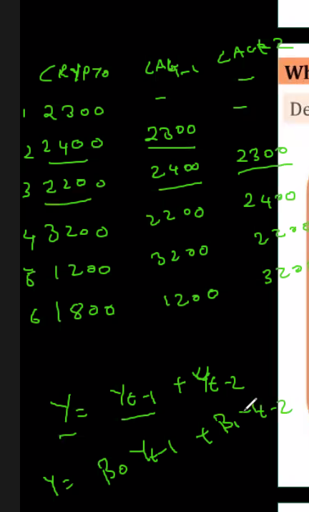

**RNN**

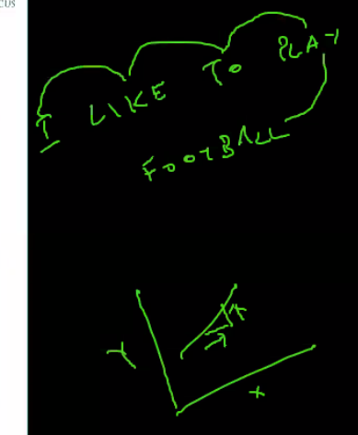

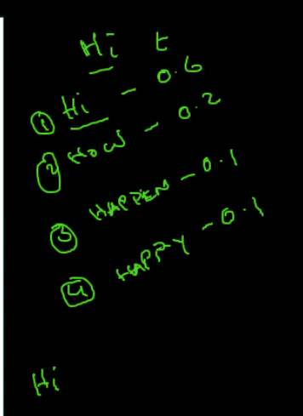State S

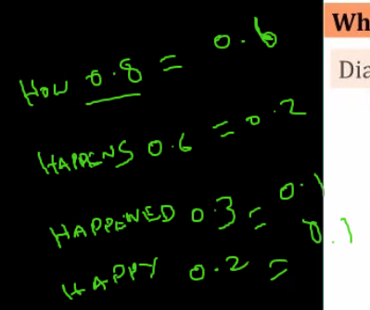 St-1, Weights are impact of previous output

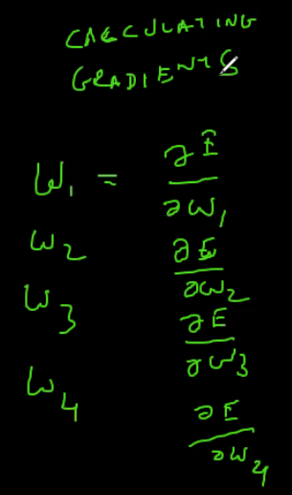How each weight contribute to errors

**Date: 09-02-2022**

**LSTM**

How much far back in time that it model needs to go is **temporal dependency**.

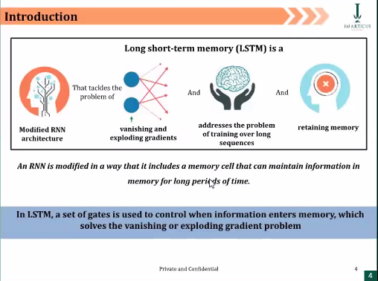

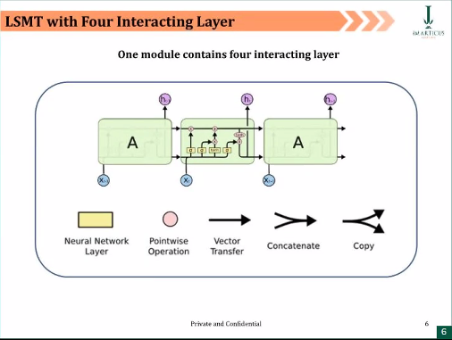

Steps

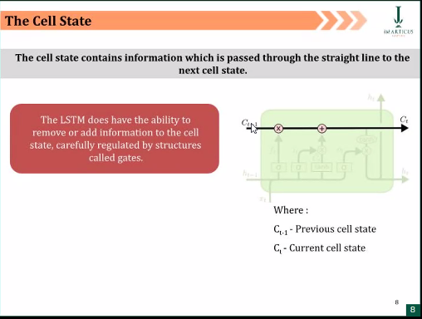

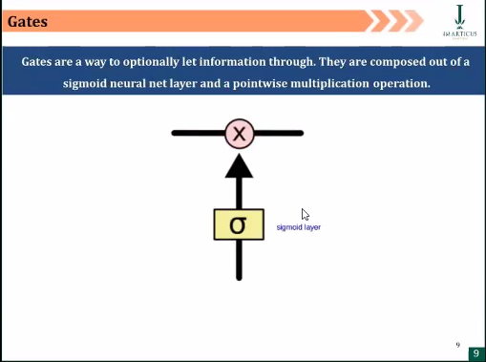

Checks for Relevancy, How far back it is needed to go, which words needed to be remembered and forget through word embeddings - Forget Gate

0 – Chuck word out

1 - Relevant

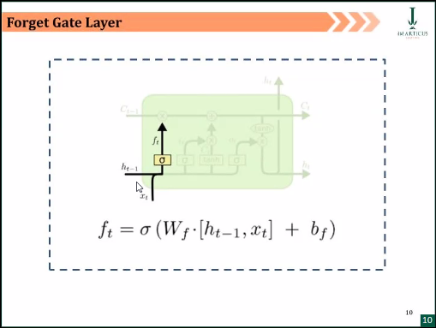

Takes Added key input, along with new input (related info)

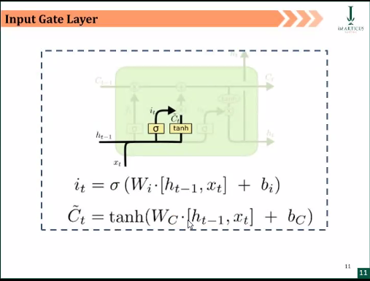

Remove irrelevant words. Then all related info is passed as current state to the output layer.

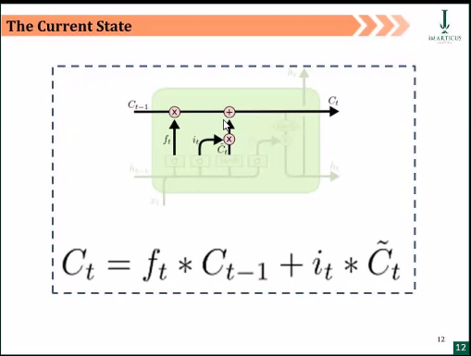

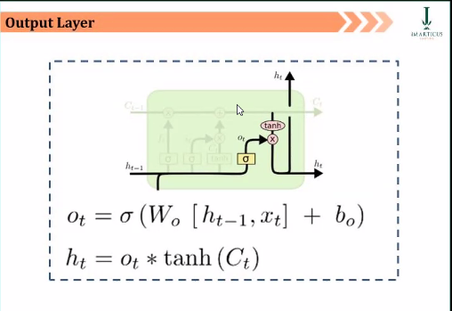  
Generate and Transmits output to the next cell.

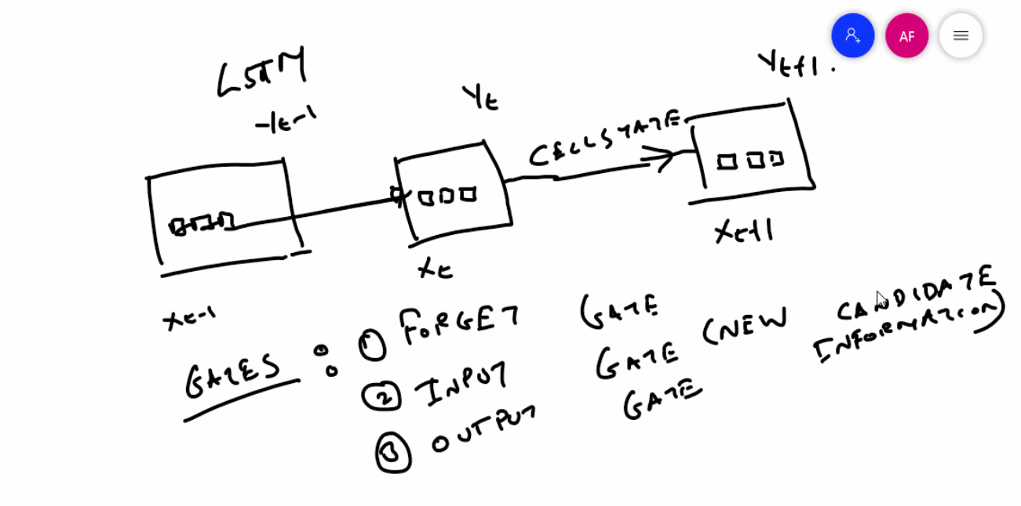

Data1) Structured: 2 Dimensions (Rows and Columns) - Homogenous/Linear relationship: KG Classroom. Statistical Models - Hetrogenous/ Non Linear: Machine Learning2) Unstructured: n dimensions: Deep LearningApproach:1) Load the data (images, text, videos....)2) Prepare and transform as required3) Set up the DL model - Tune hyperparameters Approach:1) Load the data and check shape of data2) Set up of data as tensors3) Initialize a model - Sequential: Sequence of layers - Functional: Multi models. Transfer learning (VGG16, VGG19, Inception..)4) Set up the layers - MLP: Dense Layers, Dropout, Regularization - CNN: Convolutional layers, Pooling layers, flatten etc. - RNN: Simple RNN Layer, Bi-directional RNN, LSTM - LSTM:.....5) Compile - Optimizer: SGD, ADAM, RMSProp - Loss Function: Regression or Classification - Accuracy: Classification problem - Checkpoint6) Fit - Train Dataset - Test dataset - Epochs (iterations) - Verbose: 1,2,3....7) Predict - predict for new data